4th Class: Answers for Week 9
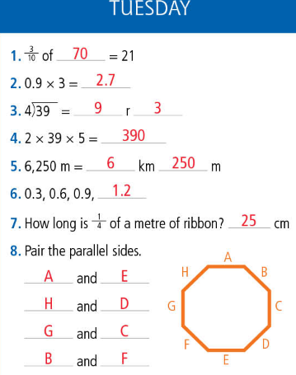
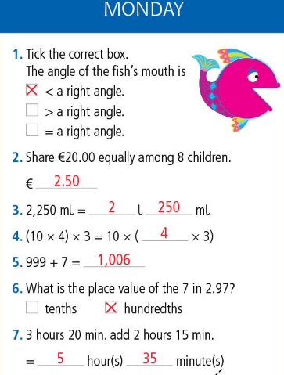
  - Mental Maths
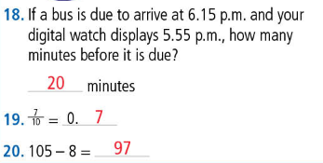
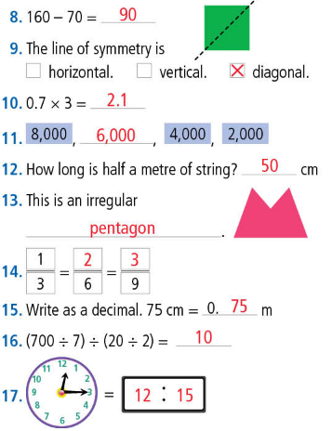

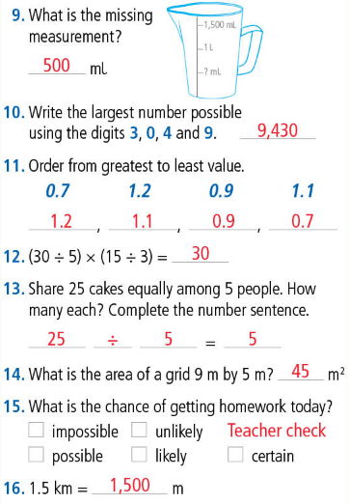

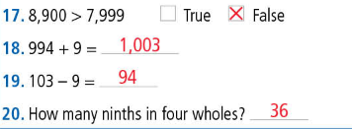

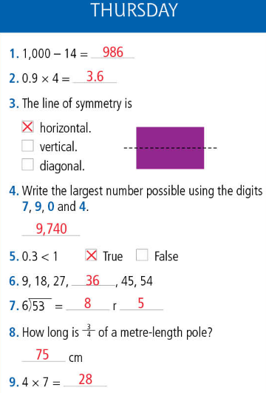
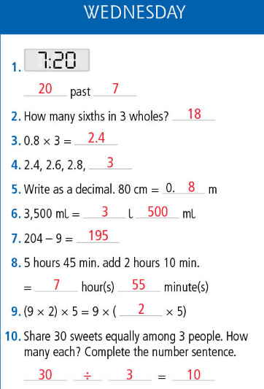

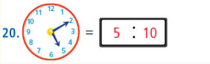
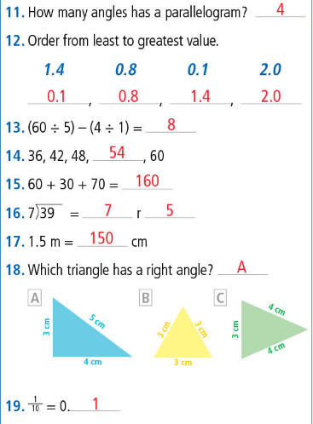

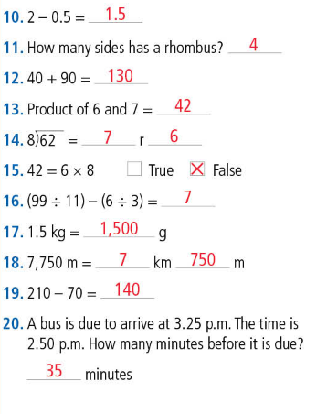

  - Cracking Maths

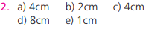

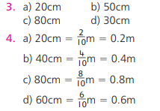

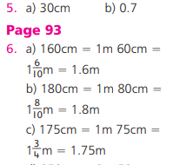

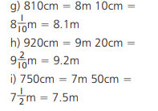

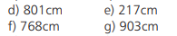
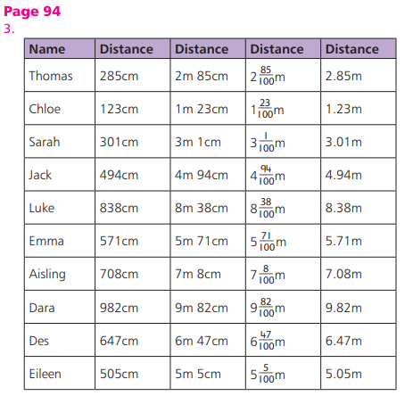

  - Abair Liom
Page99
A.
- Chuaigh an teaglach go dtí an sorcas.
- Bhí an sorcas ar siúl i bpuball mór.
- Ní fhaca Daidí an moncaí.
or Ní fhaca Daidí é.
- Bhí na heilifintí ag damhsa.
- Thaitin an Sorcas leis na páistí.
- Bhí brón ar Dhaidí mar bhí sé fliuch báite.

Page 100
C.
- Bhí brón...
- Bhí áthás ar Shíofra...
- Bhí eagla ar Sheán...
- Bhí imní ar Mhamaí...
- Bhí ionadh ar na buachaillí...
- Bhí fearg ar Oisín...

D.
- Go tobann
- Bunoscionn
- Bunoscionn
- Go tobann
- Go tobann
- bunoscionn

Page 101
F.
- Ní raibh. Bhí hata buí le spotaí glasa air.
- Ní raibh. Bhí gúna glas agus riteoga bána uirthi.
- Ní raibh. Bhí bróga ollmhóra dearga agus carbhat le spotaí air.
- Ní raibh. Bhí hata ard agus cóta fada dearg air.

  - St. Patrick Comprehension
- St. Patrick was born in Wales.
- Saint Patrick used shamrocks to teach people the Holy Trinity- The Father, The Son and The Holy Spirit
- Saint Patrick was very poor. He worked as a slave for six years.
- We celebrate St. Patrick’s Day on the 17th of March. St. Patrick died on this date in 461.

  - Grammar: Here/There/Where
- I am sure that is where I left the book.
- We are only here for a couple of days.
- Do you know where I could buy some new laces?
- Where is the nearest train station?
- We can sit over there in the shade if you would prefer.

