4th Class: Week Beginning 8th March 2021
 | Monday Zoom @ 9am | Tuesday | Wednesday Zoom @ 9am | Thursday | Friday
English | Exploring Spelling- Unit 12  - Read word list  - Red box pg 50  Reading- St. Patrick  - Read comprehension- attached.  - In your English copy, answer Q1-6 | Exploring Spelling- Unit 12  - Green box pg 50  Reading- St. Patrick  - Read comprehension- attached  - In your SESE copy, draw a comic strip showing the timeline of St. Patrick’s life.  (see example below- use all/some of the sentences & draw pictures) | Exploring Spelling- Unit 12  - Blue box pg 50  Grammar- Here/There/Where  - (See below for activity) | Exploring Spelling- Unit 12  - Pink box pg50  Narrative Writing-  ‘A Fall’  or  ‘A Fire’ | Exploring Spelling- Unit 12  - Pyramid Words- Write 5 of your spelling words in the shape of a pyramid.  e.g. clue  c  cl  clu  clue
Maths | Mental Maths- Week 24  **(see below- fraction of a number example, equivalent fractions, place value of decimal numbers)**  Cracking Maths- Length  - Page90- Q1 orally  Q2  Read bottom of page  - Find some items in your home that are approximately 1m in length. Ask a parent to measure your height. Record your height in your Math’s copy.  - Page 92- Q1-2  Tables: x10 | Mental Maths- Week 24  Cracking Maths- Length  Learn:  ¼ m = 25cm  ½ m = 50cm  ¾ m = 75cm  1m = 100cm  - Page92- Q3, 4 (a)-(d), 5  - Read yellow boxes  - Page 93 Q6 (a)-(c)  Tables: x10 | Mental Maths- Week 24  Cracking Maths- Length  - Page93 Q6 (g)-(i)  - Read yellow boxes  - Q1 (a)-(c), (g)-(h)  - Q2 (d)-(f)  Tables: x10 | Mental Maths- Week 24  Cracking Maths- Length  - Page 94 Q3- draw and complete grid  Tables: x10 | Mental Maths/ Cracking Maths-  corrections  Revise  ¼ m = 25cm  ½ m = 50cm  ¾ m = 75cm  1m = 100cm  Tables: x10
Gaeilge | Abair Liom-  - Watch video ‘An Sorcas’  Pause & repeat sentences.  - Léigh lth98 ‘An Sorcas’  - Pg99 (A) Q1-3  (see translations below) | Abair Liom-  - Watch video ‘An Sorcas’  - Léigh lth98 ‘An Sorcas’  - Pg99 (A) Q4-6  (B) – see below | Abair Liom-  - Léigh lth98 ‘An Sorcas’  - Pg100- (C) + (D)  (see translations below) | Abair Liom-  - Watch video- ‘Comhrá’  Pause & repeat sentences.  - Pg101- (F) | Abair Liom-  - Pg101- Léigh ‘Comhrá’  - Pg 102- (G)- Practice ‘An bhfaca..?’ questions- answer questions orally only
SPHE | Wellbeing Craft-  ‘Things to Look Forward To’ Jar  - See attachment ‘Wellbeing Craft’ | Wellbeing Craft-  ‘Things to Look Forward To’ Jar  See attachment ‘Wellbeing Craft’ | Mindfulness Colouring-  - Play Music  https://www.youtube.com/watch?v=5HrkXT5Bc9E  - Spend ten minutes colouring ‘Mindfulness Worksheet’.  (If you cannot print the worksheet, draw a picture) | Mindfulness Colouring-  (continue on from yesterday)
  - Gaeilge
An raibh _____ air / uirthi? (Was he/she wearing _____?)
Bhí _____ air / uirthi. (He/She was wearing _____)

An bhfaca tú an ____? (Did you see the ___?)
Chonaic mé an ____. (I saw the ____.)
Ní fhaca mé an ____. (I didn’t see the ___.)

Page99 (B)
Cad a tharla ansin? (What happened then?)
- Write:

Bhain Daidí a scaif agus a hata de.
Rinne Mamaí cúpan tae do.

- Draw a picture
(Daddy took off his scarf and hat.
Mammy made a cup of tea for him.)
Abair Liom – Monday/Tuesday - Page99 (A)
- Cé a chuaigh go dtí an sorcas? (Who went to the circus?)
Chuaigh ..........

- Cá raibh an sorcas ar siúl? (Where was the circus on?)
Bhí an sorcas .............

- Cén duine nach bhfaca an moncaí? (Which person did not see the monkey?)
Ní fhaca ..........

- Cad a bhí ar siúl ag na heilifintí? (What were the elephants doing?)
Bhí na ..........

- Ar thaitin an sorcas leis na páistí? (Did the children enjoy the circus?)
Thaitin ..........

- Cén fáth a raibh brón ar Dhaidí? (Why was Daddy sad?)
Bhí brón ............. mar bhí sé fluich ......... .

Wednesday
Upside down
suddenly
happy sad angry scared surprised worried
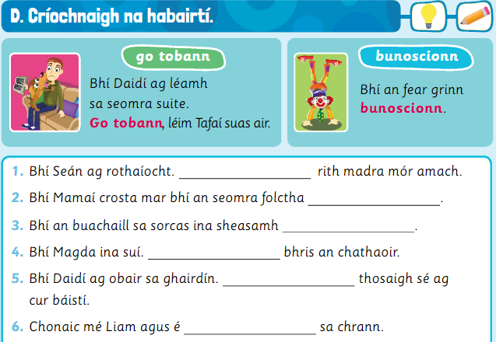
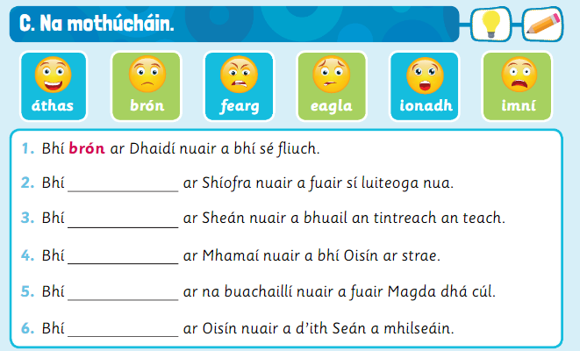
2. Síofra was ___ when she got new leggings.
3. Seán was ___ when lightning hit the house.
4. Mammy was ____ when Oisín was missing.
5. The boys were ____ when Magda got two goals.
6. Oisín was ____ when Seán ate his sweets.

- Seán was cycling. ______a big dog ran out.
- Mammy was cross because the bathroom was ______.
- The boys in the circus were standing _____.
- Magda was sitting. ______ the chair broke.
- Daddy was working in the garden. _______ it started raining.
- I saw Liam and he was ______ in the tree.

  - Maths-

Mental Maths: Fraction of a Number Example
A quicker way is simply to divide the 16 by the 4, without using counters at all.

¼ of 16 = 16 divided by 4
Therefore, ¼ of 16=4

¼ of 16 =

You can lay out 16 counters and then separate- or divide- them into four
equal parts to see how many counters would be in one quarter,
Like this:

Answer = 4

Mental Maths: Place Value- Decimals
What is the value of 5 in 2.56?
Units | Tenths | Hundredths
2 | 5 | 6

5 = 5 tenths

Mental Maths: Place Value- Decimals
What is the value of 6 in 2.56?
Units | Tenths | Hundredths
2 | 5 | 6

6 = 6 hundredths

  - Mental Maths- Equivalent Fractions

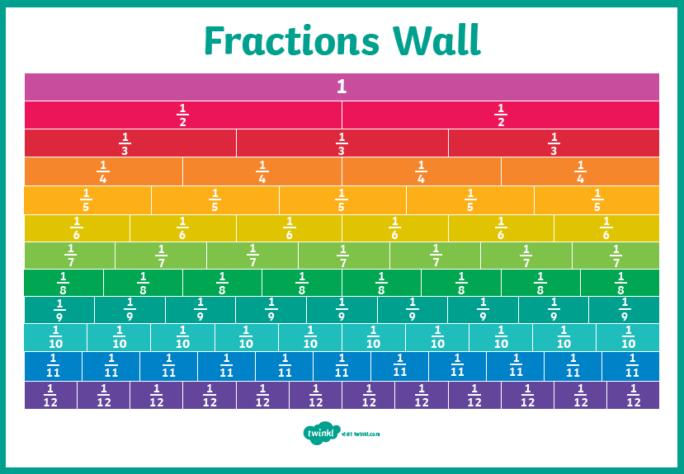

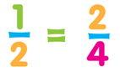

You can use your fractions wall.
or

(You must multiply by the same number on the top and bottom)

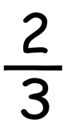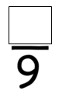
x3

x2

x3
x2

  - English- (Tuesday)
  - Comic Strip example-
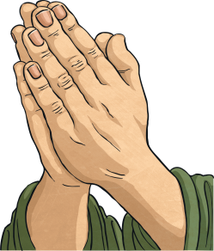

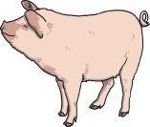
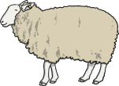

Patrick escaped from Ireland and got back to Wales.
Patrick always thought about his life as a slave in Ireland and he continued to pray to God.

Patrick had a very lonely life and spent most of his time praying.

When he was 16, he was captured by raiders and sold as a slave to an Irish farmer called Milchu in County Antrim.
Patrick had to mind sheep and pigs, on a hill called Sliabh Mis and he wasn’t treated very well.

St. Patrick is thought to have been born in Wales in the 5th century.

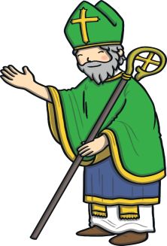
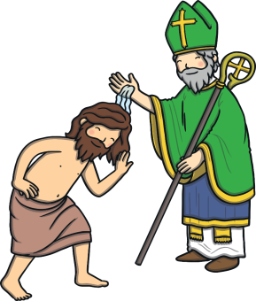

St. Patrick died on the 17th March 461.
St. Patrick used the shamrock to explain about the Holy Trinity to Irish people, the three parts of the shamrock represneting The Father, The Son and the Holy Spirit.
Saint Patrick studied to become a Christian priest and returned to Ireland to teach people about Christianity.

  - English- Grammar Lesson (Wednesday)
We use here, there and where to talk about a place.

Here means this place, there means that place and where means what place.

- Here: We are here in this place.
- There: It is there in that place.
- Where: Where is the remote control? (What place is the remote control?)

- In your English copy, complete each sentence using here, there or where.

Title: Grammar- here, there or where

- I am sure that is _____ I left the book.
- We are only ______ for a couple of days.
- Do you know _____ I could buy some new laces?
- _____ is the nearest train station?
- We can sit over ____ in the shade if you would prefer.

